# Win Your [Satta Matka](http://sattamatka.org/) Game Online

Engaging the satta matka is something that many people dream about, but very few people have the experience. Now I'm not talking about winning a small satta matka here and there, no, I'm talking about winning the big jackpot satta matka at one of the most popular lotteries like Powerball or EuroMillions. It has become clear to me these days that more and more people are playing online satta matka, in fact it is worth buying some tickets from time to time for a big satta matka, especially if the Grand Prix is not released for a while. Yes, I know the chances of winning the big jackpot prize are low, but I find it very attractive and exciting. All at a very low price - some satta matka tickets cost only a few dollars.

[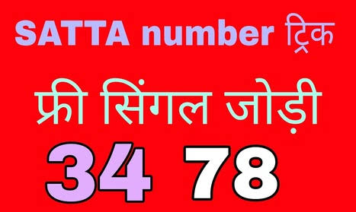](http://sattamatka.org/)

If you get free tips and tricks then click on image satta matka, dpboss, satta king, matka result, satta matka result, satta batta,

I was not interested in playing satta matka until it was possible to buy satta matka tickets online. Why would you ask Well, before that I could only take part in the satta matka available in my country. I felt it was a bit limited, as I said, I particularly enjoyed playing the jackpot satta matka, and most of them were foreigners. Sure, our national satta matka had a good payout schedule, but when considering the amount of money in a major international [satta matka](https://sattamatka.org/), you are not close to potential profit.

Buying satta matka tickets in my city usually involves queuing at a grocery store and physically buying satta matka tickets from the box office. The satta matka ticket itself was a card that you can easily lose if you simply fall out of your pocket at home. This does not happen very often, and there are still concerns that a meaningless piece of paper, easily forgotten anywhere, can forever secure your financial future.

Nowadays, things are different. Yes, there are still a lot of people who want to buy real satta matka tickets and then watch the satta matka return on television. It's not time for me. I can buy all my satta matka tickets online through only trusted satta matka brokers! Satta matka brokers are the only companies that sell legal and official satta matka tickets online through their websites. These companies or websites usually provide the opportunity to buy satta matka tickets for international lotteries because they have a local agency in the country where the lotteries are run. For me, this is the perfect solution because I can now play in practically all lotteries around the world and also choose to play in this satta matka, which currently has the largest jackpot!

There are also some other key benefits of playing online satta matka using the method you mentioned. Perhaps most important in terms of security. There is no chance that I will lose the satta matka ticket again because the company - the satta matka broker - from which I have made a purchase will keep my tickets and track any profits without lifting a finger! This is probably one of the biggest benefits of playing an online satta matka - a variety of game options and security.

As you have guessed so far, I might be playing online versus offline, and that is because you are sitting at your computer comfortably at home.

[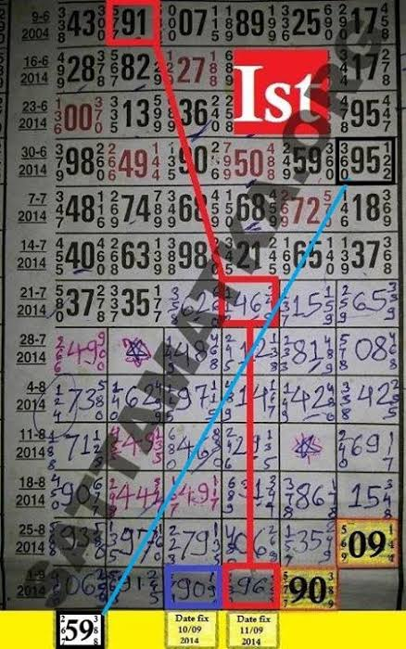](sattamatka.org)

You will get details information, [click on image](sattamatka.org) satta matka, dpboss, satta king, matka result, satta matka result, satta batta,

# [What to do to Win satta matka game win?](http://sattamatka.org/)

There are many people who play satta matka, but many do not have a chance to win Pluto. Some players have won multiple times, indicating that they are very interested in the satta matka system. Many satta matka winners have systems to win.

Many people can buy a ticket, earn money, pick up the money they win and call it a day. This is not the best way to use it because satta matka winners have learned it. If you play for one dollar and win $ 20, you need to return every twenty dollars you were redeemed in the satta matka to win a big prize. With this method, you end up losing, you will actually lose only the one dollar you used to buy your first ticket. The system has given several lucky winners several trips to the Satta matka Awards office. Using your profits to buy more tickets will help reduce the actual actual loss as if you were buying and leaving a stock, and a loss until you get that stock. Not implemented.

**Understand The Posibilities**

Successful losers, and many of us at one time or another, will need more than diligence to overcome the challenges of a successful satta matka. Consider the satta matka as if it were your business. To understand the possibilities of a satta matka game, feel free to use more hours to improve your success. Informed gambling gives you a better chance of winning big prizes.

**Loss Of Income**

Some people say that you should treat the lotto the way you should invest almost any other investment, not a rare opportunity. You will not play tickets here and there and when you play the satta matka you will give yourself a good chance to win. For any real chance of success in the satta matka, you should put money into a good [satta matka](https://sattamatka.org/) system.

Many [satta matka](http://sattamatka.org/) winners spent all their money and went bankrupt without a home. It is also important to know what to do when you win the satta matka. If you bet and don't spend most of what you earn, you won't have to worry about any loss of income. Obviously you want to buy some things, but you won't spend all your profits.

**Tax Deductions**

Invest some of your profits and use some of them to reinvest in satta matka investments. It's not a good idea to throw a ticket. When you win a satta matka, you can use the cost of all of these winning satta matka tickets to offset the taxes you may have to pay on money earned from your satta matka profits. Some taxes can be deducted as soon as you win, though they are usually not enough, and if you win in many big lotteries, you don't want to be owed to the IRS.

**Regular Commitments**

You should use common sense every time you play lotto. Those who play more games than it definitely increases their chances of success. You should not spend money on essentials. If you buy more tickets, your chances will not improve, but it does not hurt to buy more lotto tickets because this money is not for your regular commitment.

To win the biggest prize in the satta matka, the odds need to be corrected in your favor. If you are a fully-fledged satta matka player, there are other steps you can take to get a better chance of success. You can use computer applications that analyze the most likely numbers you can play. However, it does not matter to the system you are using or especially to the applications you are using as there was certainly no stupid approach to winning the satta matka.

The odds of winning a multi-national satta matka, such as power balls, in the United States are almost one in every hundred and twenty million dollars, so playing just one game a week will not guarantee that you will win anything. But life is fraught with danger, so obstacles should not let you scare you. As they say, someone wins, and it can happen. Stay positive on how to win the [satta matka](http://sattamatka.org/) more consistently, because big game is only a matter of time.

**[johnpeter00900](https://www.vingle.net/johnpeter00900)**

**What is Satta Matka**

Satta is a type of gambling. Some groups say it Matka. Satta Matka (satta-matka) is illegal in India. But still many people place bets on Matka.

**Types of Satta**

There are various markets in Satta.

* Disawar (or Desawar)
* Gali Satta
* Faridabad
* Gajiyabada
* Main Mumbai
* Warli Matka
* Kalyan Matka,
* Milan matka,
* Rajdhani matka,
* Madhur matka,
* syndicate matka, prabhat matka, time matka, rajshree matka, new bombay matka, main      ratan matka

**Term in Satta Matka**

1. Khaibal:- To take bets.
2. Bindi:- bindi means 00 in the last digit like 10, 80, 30, etc
3. Munda or Single means single digit like 1,2,3,4,5 etc
4. Jodi: All numbers are called Jodi from 0 to 100.
5. Farak The Farak is how many different from close result to open result (e.g.if the jodi/pair is 57, 7-5; the farak is 2; some another: “73” is 13-7 – 6 )

**Satta Matka is a Game of Luck.**

Here I will disclose how to locate your fortunate number right now dominate Big **Satta** games

Indian round of karma, **[satta matka](https://sattamatka.org/)** depends on irregular number choices and offers. Any way to win your needs the fortunate number. A significant wagering pattern in the subcontinent the round of **sattamatka** necessitates that you pick the correct number for dominating the match and turning into the Satta lord all the while. It will likewise be exceptionally remunerating as the victor takes all right now after got **the [satta matka result](https://sattamatka.org/)** that could be a gigantic monetary profit for you.

C:\Users\user\AppData\Local\Temp\msohtmlclip1\01\clip_image001.gif

**The Same in Both Games :**

On the whole **Satta Matka results**are based on the right choice of the number. It is the same for both formats of the game; the **Kalyan Matka** introduced by Kalyanji Bhagat in 1962 and Worli Matka introduced by Ratan Khatri in 1964. Thus the **[Satta Matka tips](https://sattamatka.org/" \t "_blank)**offered by the experts also revolve around the selection of the winning number for the game. It is somewhat similar to selecting the number in spinning roulette and other games in the online and offline casinos in the western world.

**Relevance of Matka King Charts:**

To play the game and converting the results into winning one you need to make the right **Satta Matka guessing.** While a large part of the same is dependent on the use of common sense there is also a need for learning certain things and tricks of the trade for making the right guesses. That is where both traditional **Satta Matka chart** as well as the **Kalyan matka chart**can come up very handy. Only a reliable and reputable site can offer the best information available for the purpose. Going through the gaming trends, bidding in different games, and results generated helps the player take an informed decision about guessing. Once the base is formed the player can use common sense to find the best possible number that can easily turn out to be his or her lucky number rendering the player the **[satta king](sattamatka.org)**in the process.

C:\Users\user\AppData\Local\Temp\msohtmlclip1\01\clip_image001.gif

**Lucky the Combination of Guesswork and Calculation:**

Lucky number in the game of **Satta matka**does not depend on the luck of the player alone. Intelligent guesswork and calculations are as important as the luck of the gamer. While correct **Satta Matka guessing**can be developed by carrying out practices and exercises in this regard based on reasoning, the **[Satta Matka Kalyan chart](https://sattamatka.org/)**can help refine the calculating skills of the gamer effectively.

C:\Users\user\AppData\Local\Temp\msohtmlclip1\01\clip_image001.gif

Of course for winning the game you will need some amount of luck but it is not luck alone but taking an informed decision with all data deciding the trend available that can work well for the player to win and become the king by choosing the real lucky number.

[**How to play Satta Matka?**](http://sattamatka.org/)

**Satta Matka** is played under diverse markets like **Kalyan Matka,** morning Janta, Kuber Balaji, time syndicate, Milan day, Balaji day, kamdhenu, Delhi Rajdhani day, syndicate night, Janta day, main rattan Bombay, Milan night, syndicate night, Rajdhani, shubhank night, etc. all these jointly form the India Satta Bazar. There are essentially 5 games played under all these markets, these being, Single, Jodi, Panna, Sangam, half Sangam. All these games or one may say variations, are different parts of the same result. The complete result of a Matka is an 8 digit number. People bet on any number out of these 8 numbers, depending upon what variation they’re betting on. Each variation has a different rate according to which people wager. Let’s say if 123-69-324 is a **[Matka result](http://sattamatka.org/)**, and if you want to bet on Jodi, then 69 is called a Satta Jodi. The rate of Jodi is 1:90, which means you get 90 times the amount if you play for 1 rupee.

**How can sattamatka help you win satta matka?**

[**Sattamatka**](https://sattamatka.org/) provides a lot of different features to the game, basically, it provides its users with all the help they need to win at it. With Online **Satta matka** being the need of the hour, our website contains all the information on how one needs to play the game and not just this but delivers the live and fastest **Satta Matka results**, so that people have a hassle-free and convenient gaming experience. It’s because of the **satta results** that people find this game better than how it was before.

**Sattamatka** is one such website that has everything for everyone, also get free tips and tricks for **Dpboss, Satta king, Kalyan Matka, Satta matka** as well you can get fastest **Satta matka result, Matka king, Satta result**  from beginners struggling to play to people already playing it, we provide 24\*7 assistance to our players. Technology has made Matka emerge to a much larger extent than what it was when it started, but what still remains is, it still is the most preferred gambling game amongst all the other ones. So, don’t wait up anymore, and win Satta Matka with us.

If it is helpful to go to more above information [Click here](https://sattamatka.org/)

If you are getting free tips and tricks on [Satta Matka | Dpboss | Satta King | Matka Result | Satta Matka Result](http://sattamatka.org/) bit.ly/2VsMfOH

[Click here](https://sattamatka.org/)

[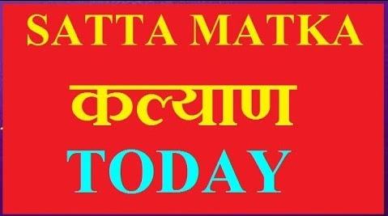](sattamatka.org)

>>>>>>>>>>>>>>>>>>>>>>>>>^^^^^>>>>>>>>>>>>>

Matka is a very old gambling game in India and some other countries as well. It is a lottery game played on numbers, where numbers are drawn and people wager on these numbers to earn big money.

History of Satta matka.

The records of Satta Matka, takes us back to 1960s, where people positioned bets on the opening and closing rates of cotton that was being shipped from Bombay cotton exchange to New York cotton exchange. A lot of people back then grew addicted with this practice, and matka become a craze amongst people. But due to a lot of problems, this exercise was once shut down. This recreation had turn out to be so popular already; that people began rooting for it, so one man responsible on bringing it back into the business was Ratan Khatri.

Rattan Khatri came up with this game again, however with a few changes, this time, three numbers had been drawn from 0-9 instead of one from a big earthen pitcher called matka. Hence, the name Satta matka, and individuals whose betting number matched the drawn numbers would win.

With time passing by and development in technology, online satta matka, came into subsistence. Seeing it grow with advancement in technology, more people using the technology got attracted towards this game. What attracted people to this game were the new features that were added which were not present previously? Due to it’s characteristic like tips and tricks, guessing forums, panel chart and range of markets, online satta matka is gaining a lot of reputation.

Matka Business operated in Gujrat Ahmadabad.

This is for Keyword “SAtta King”

Who is Satta King?

[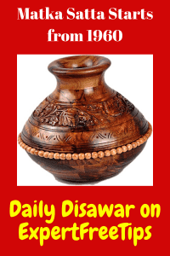](https://sattamatka.org/)

Who wins in Matka, called Satta king. (or satta-king)

Kalyan Bhagat, Ratan Khatri, Suresh G Bhagat are the founder of Matka. You can also say them Matka King (Satta-king). Matka starts from 1960 in Mumbai.

Cotton worker plays Matka at that time.

Type of Satta King

* S Satta King Online
* Satta King UP
* Satta King Online
* satta-king